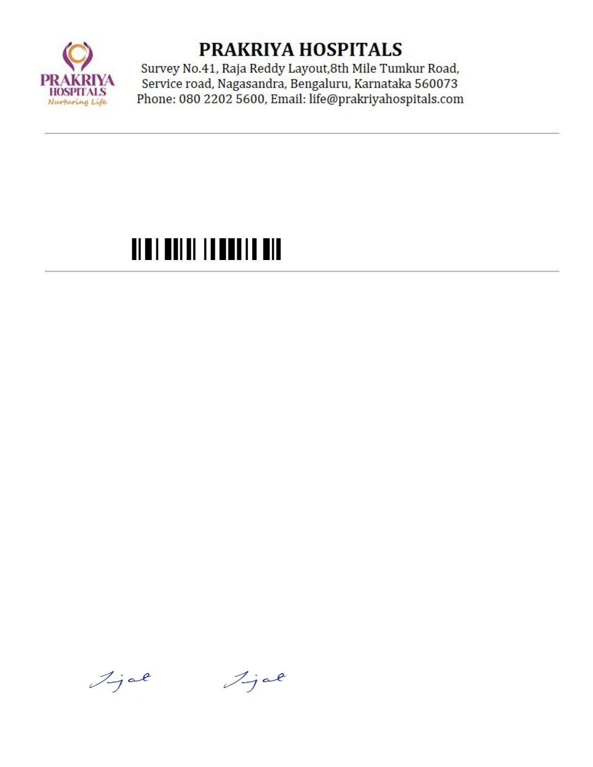

7/21/25, 9:01 AM kapoiaappi.ecwcloud.in/HEALOW/Labs/ReportForms/TempPrint/477114_21_7_2025_102_ReportPrint.html
PATIENT NAME :MRS. UMADEVI G M Bill No / Barcode. :477114 / LA25022229
Age & Sex | :76Y 0M 2D/Female | Bill Date | :Jul 16 2025 3:27PM

Reg Number | :IP/1/20250714/16/PHID220634/UHID125718 Sample | :Jul 16 2025 3:29PM
Reg Number | Receive Date | :Jul 16 2025 3:29PM

Referred By | : Dr.ANAND KUMAR M | Report On Date | :Jul 17 2025 2:49PM

Reported On | :Jul 17 2025 2:49PM | Mobile | :9845883888

Barcode | : | Verified on | :Jul 17 2025 2:51PM
HISTOPATHOLOGY
Histopathology number: H/2492/25
Gross:Received 3 linear tissue bits.
Microscopy: Sections studied shows features of infiltrating ductal carcinoma Grade II.
Impression: Features are suggestive of infiltrating ductal carcinoma Grade II.
Site:Left breast
Note:1 block enclosed.Please preserve them.
NOTE:- Investigations have their limitations. Solitary pathological/Radiological and other investigations
never confirm the final diagnosis. They only help in diagnosing the disease in correlation to clinical
symptoms and other related tests. Please interpret accordingly. This Report is not for Medico - Legal
Purposes. Printing mistakes should immediately be brought to notice for correction.
Reported by Pathologist
Dr.Sujatha Udupa. MBBS, MD
KMC No:57451
--------------------End of the Report--------------------
Dr. SUJATHA UDUPA
MBBS,MD KMCNO- 57451
Reg No-57451
Dr. SUJATHA UDUPA | Dr. SUJATHA UDUPA | PATHOLOGY
Prepared by MBBS,MD KMCNO- 57451
PATHOLOGY
https://kapoiaappi.ecwcloud.in/HEALOW/Labs/ReportForms/TempPrint/477114_21_7_2025_102_ReportPrint.html 1/2


7/21/25, 9:01 AM kapoiaappi.ecwcloud.in/HEALOW/Labs/ReportForms/TempPrint/477114_21_7_2025_102_ReportPrint.html
Reg No-57451
Verified By
https://kapoiaappi.ecwcloud.in/HEALOW/Labs/ReportForms/TempPrint/477114_21_7_2025_102_ReportPrint.html 2/2

